Question1 - Design a network with five PCs connect with a switch using a packet tracer

. Step 1:

Open cisco packet tracer software and login as a guest.

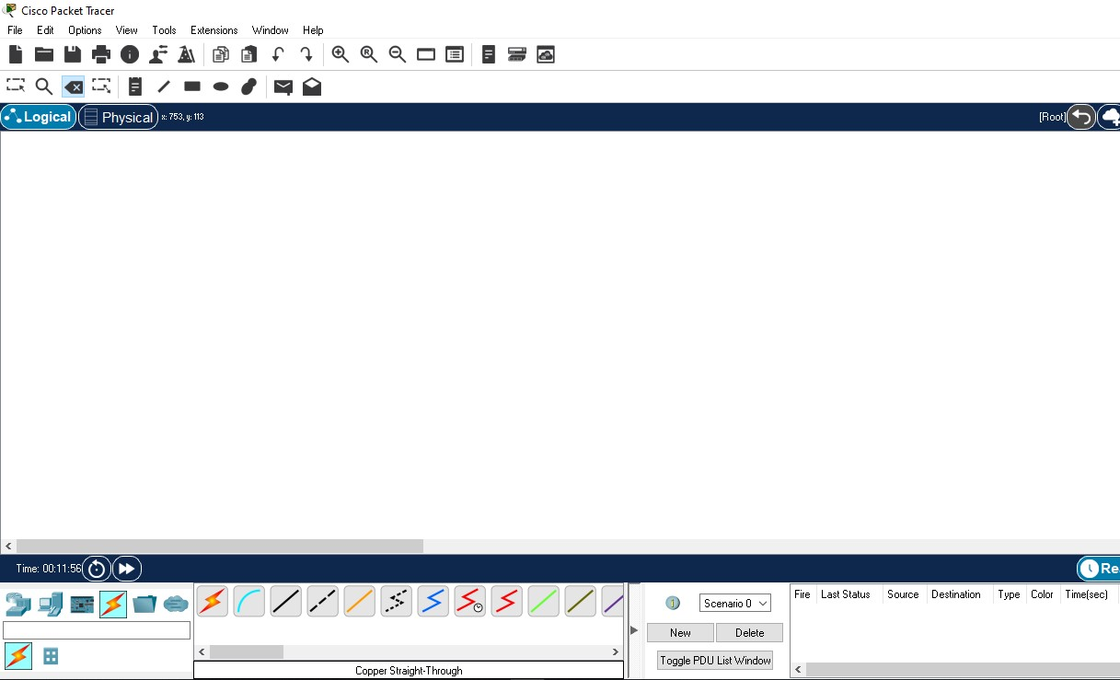

Step 2:

Go to bottom task bar and select “Network devices” and under that select switches and drag drop it to the logical board.

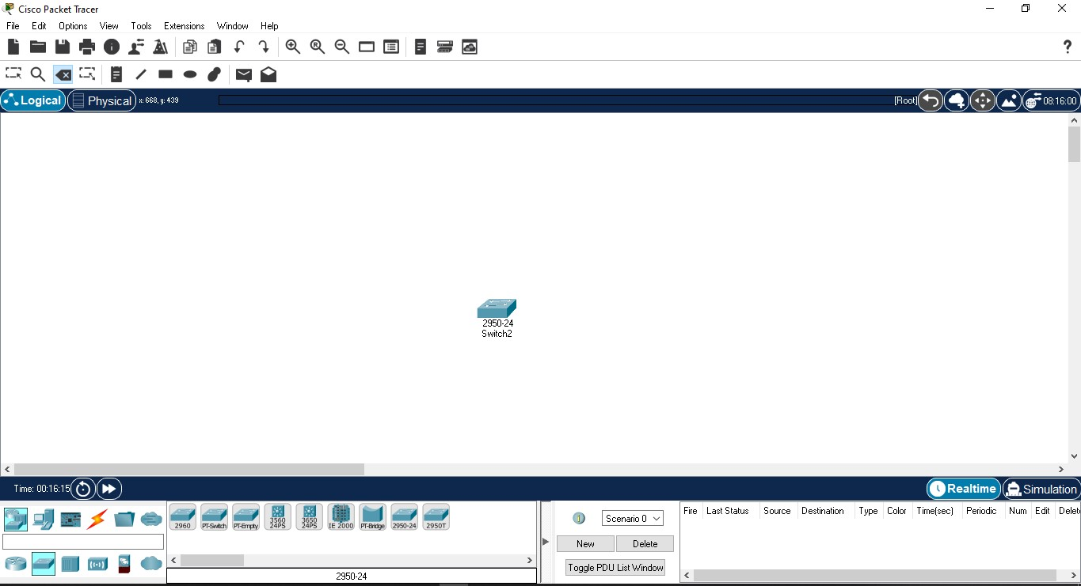

Step 3:

Now, go to “End Devices” and select PC and drag drop 4 of them into the logical board.

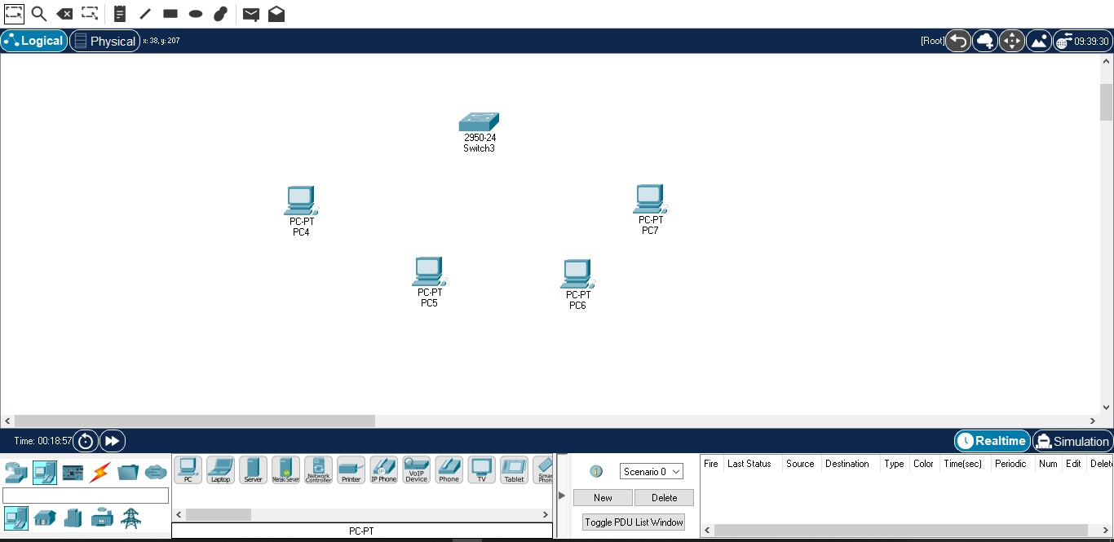

Step 4:

Now, select copper straight-through wire from the “Connections” tab and then connect all 4 pcs to the switch using FastEthernet connection.

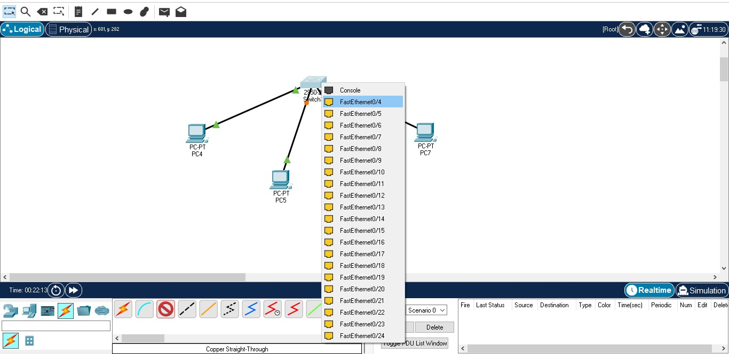

Step 5:

Next, configure the ip by clicking on PC PT PC4.

Go to the desktop tab and select ip configuration.

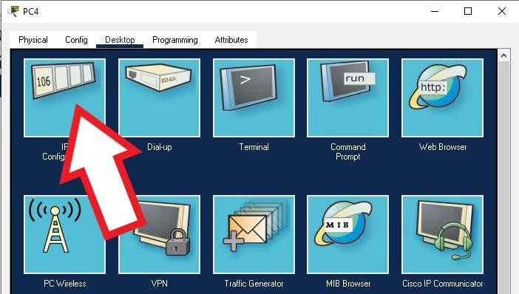

Step 6:

Set ip address for PC4 as – ip – 192.168.3.1 or 192.168._._(as your wish)

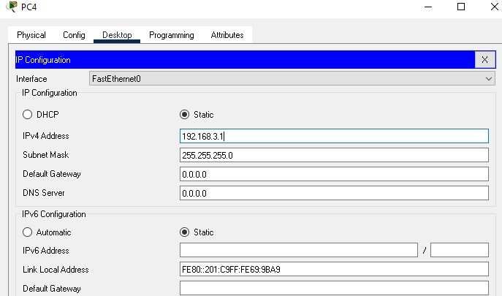

Step 7: Repeat step 6 for remaining 3 Pc’s.

Step 8: Check the connection between switch and Pc’s using command prompt.

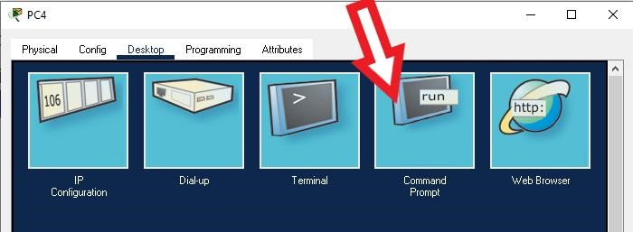

Step 9:

Open command prompt and type ping (ip of the PC selected) ping 192.168.3.1

if the output on command prompt looks like the screensnap then the switch and Pc are connected successfully

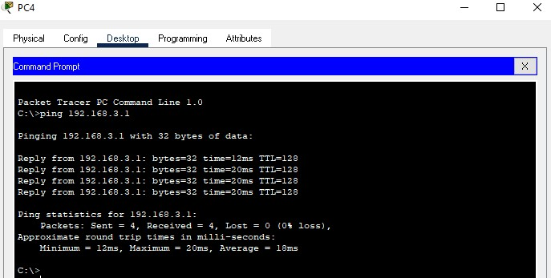

Step 10:

Repeat step 9 for remaining 3 PC’s

If any error occurs, check the ip address for any mistakes and try again and if no error occurs then your 4 PC’s and switch are connected successfully.

Question 2 -Design a peer-to-peer network with two PCs.

**Step 1-**open software packet tracer

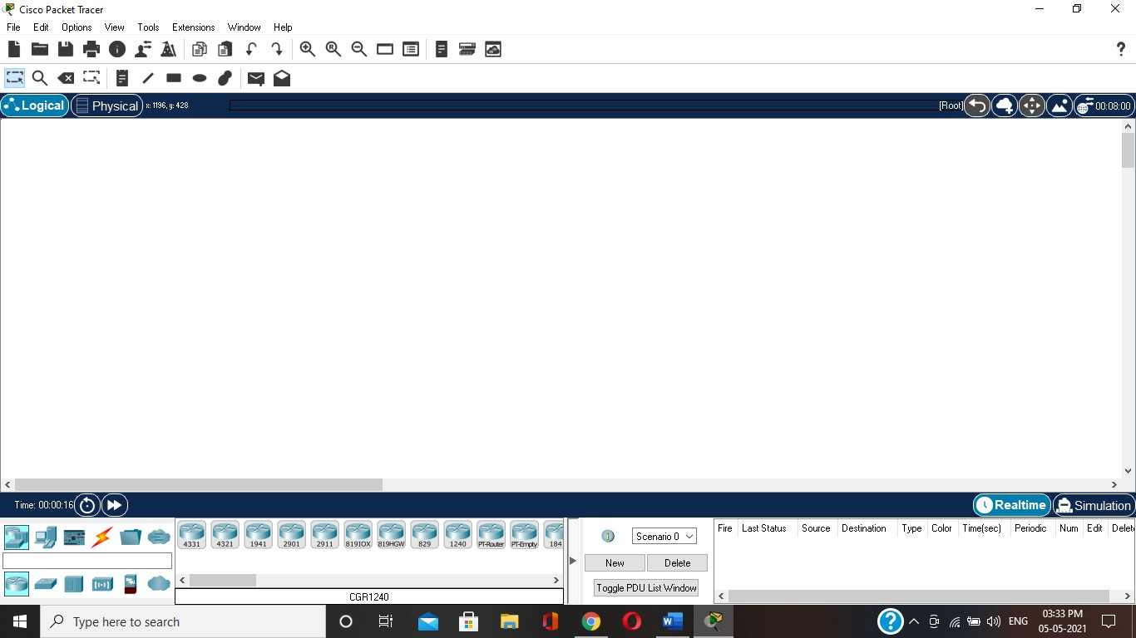

**Step 2-** drag icon general (Personal Computer) and drop to worksheets.

Choose Connection Type. click PC0 then click PC1.

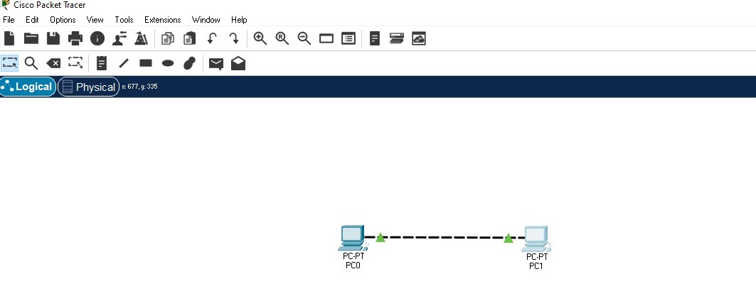

# Step 3-

Double click PC0.

Desktop tab, then click IP Configuration.

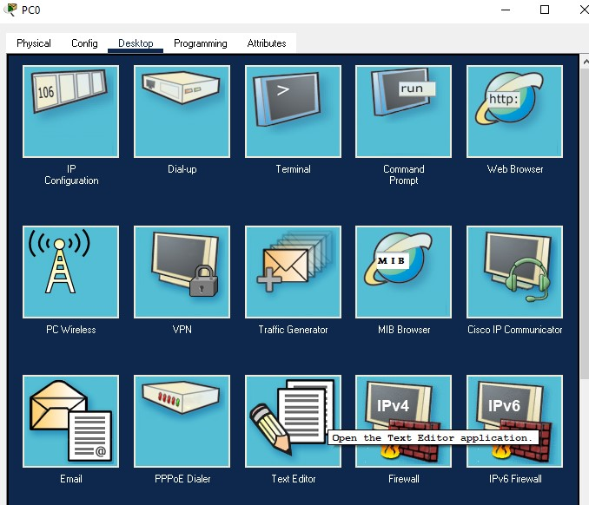

**Step 4-** Set IP Address for Subnet Mask.

IP Address PC0 = **192.168.2.1**

Subnet Mask = **255.255.255.0**

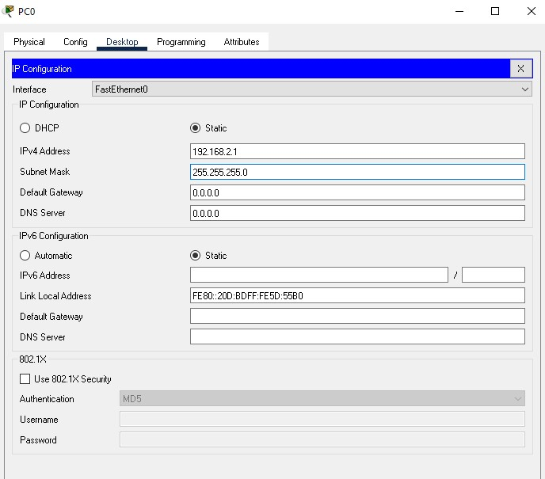

# Step 5-

close window PC0 double click PC1

Desktop tab, then click IP Configuration. set IP Address for Subnet Mask. IP Address PC0 = 192.168.2.2

Subnet Mask = 255.255.255.0

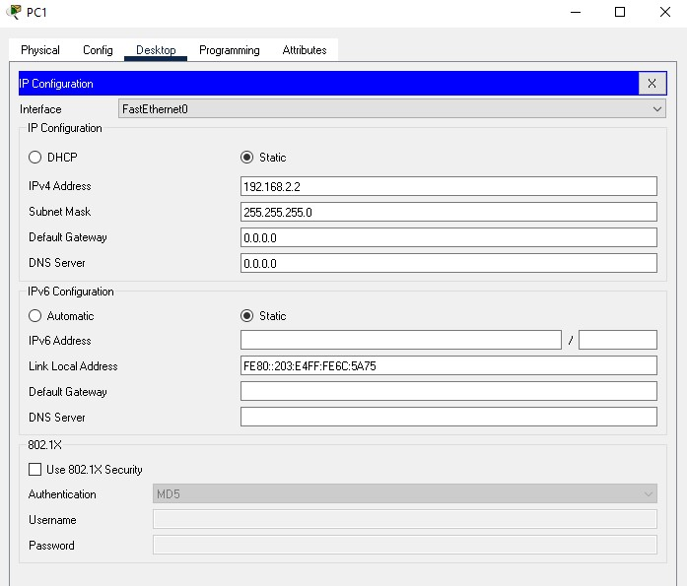

# Step 6-

Desktop tab, then click Command Prompt

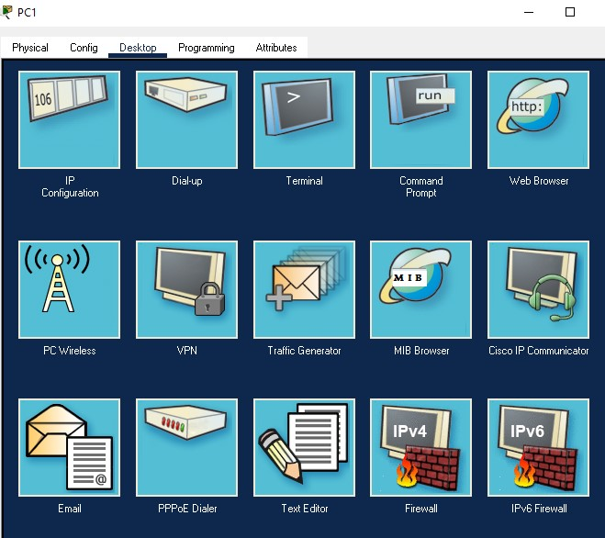

# Step 7-

type ping 192.168.2.1 then enter.

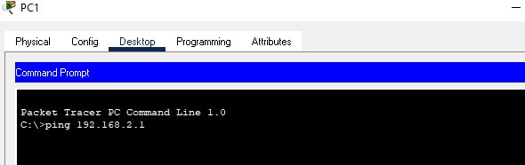

**Step 8-**  if it appears as shown below, it means PC0 and PC1 are connected and successful.

